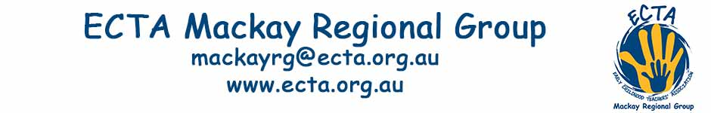ECTA Mackay Regional Group
Joining Form

Educators and those interested in Early Childhood in the Mackay Region (anything North of Rocky and South of Townsville and East of Perth) are invited to join our regional group. Joining will allow you to attend workshops and social gatherings at no cost and/or reduced cost. Only individuals are able to join the regional group.

The ECTA Mackay Regional Group aims to meet each term for PD and/or social gathering with a regional conference yearly.

Please Note: ECTA Mackay Regional Group is a branch of the Early Childhood Teachers’ Association (ECTA). Membership of ECTA is $95 for individuals and $210 for organisations. ECTA Individual and Organisational Members receive 9 no cost webinars, huge regional event discounts, 3 journals and DVD recordings of ECTA Annual Conference (Brisbane) of selected presentations. Membership forms can be downloaded from ECTA website www.ecta.org.au. You don't need to be a member of ECTA to join ECTA Mackay.

We only communicate to members via email, so you must supply an individual address on this form. Please notify us if you email address changes.

The joining fee is $5 per year (Jan to Dec) to ECTA Mackay Regional Group via cheque or direct deposit. Receipt will be emailed.

Direct Transfer  (Preferred) | ECTA Mackay Regional Group  Bank of Queensland  BSB: 124-001  Account: 2189 5572  Transfer ID: Surname & Initial
Cheque/Money Order Enclosed | Please make payable to ECTA Mackay Regional Group  and email ECTA for details

ECTA Mackay Regional Group  15 Corella Way, Blacks Beach, 4740 | Phone: 0417 915 355  Email: mackayecta@gmail.com

Submit this section with your payment (mackayecta@gmail.com)

I wish to join the ECTA Mackay Regional Group
Joining Fee is $5 per year.

Name: |  | Phone (optional):
Email (essential):
School/Centre: | Organisation Email:
Age group: | Role:
Date Paid: | Payment Method:

Office use:
Payment received date: | Added to data base date:

