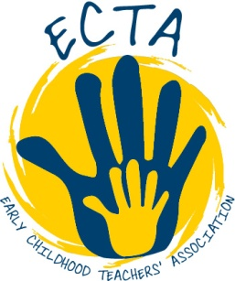
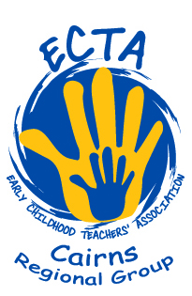
ECTA Cairns Regional Group
Invites
All Early Childhood Professionals
to
Rhymers will be readers :
This hands-on, interactive workshop explores how by introducing children to interesting and stimulating language experiences so they will develop a life-long love of reading and stories using songs and rhymes to introduce children to the magical world of reading.
with Sue Lewin
And

Dream, draw, design, make:-
From STEM to STEAM in early years Education.
This hands-on interactive workshop explores the integration of engineering and the arts in Early Years curriculum. Engineer and writer Andrew King, and musician and early years educator Sue Lewin combine their knowledge and experience in their chosen fields to lead participants through practical activities, philosophies, songs and creative thinking for children. Dream it: -STEAM IT.

with Sue Lewin & Dr Andrew King
Saturday 12th March 2022
7.30 am-1.00pm
(We will open at 7.30 am to start promptly at 8.30am)
Rydges on the Esplanade,
209-217 Abbott Street
Cairns
Morning Tea will be provided.
Dairy free & gluten free options will be available
A certificate of attendance will be emailed after the day.
Cost:
1 session
$5 Qld ECTA members $10 Regional Group members $15 Non-members
Both sessions
$10 Qld ECTA members $15 Regional Group members $20 Non-members

Please return the completed registration form by 5.00pm on Wednesday 9th March 2022, via email to ectacairns@gmail.com or post to P.O. Box 36, Earlville. 4870

Australian Professional Standards for Teachers: 1, 2 ,3 ,6 & 7
NQS Quality Areas: 1, 3 & 6

Statement from Rydges
For the health and safety of our guests and staff in our Australian hotels, only fully vaccinated guests are allowed to enter the premises and its venues and outlets. Guests from lockdown areas are not permitted to enter and proof of address and vaccination must be produced when requested via the approved state government app. Please visit https://www.health.gov.au/ to get the latest advice before booking or travelling to our Australian hotels.

